PIZZA SALES SQL QUERIES

KPI’S
- Total Revenue
select sum(total_price) as Total_Revenue from pizza_sales;
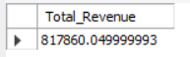
- Average Order Value
select sum(total_price)/count(distinct(order_id)) as Avg_Order_Value from pizza_sales;
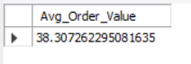
3.Total Pizzas Sold
select sum(quantity) as Total_Pizza_Sold from pizza_sales;
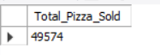
4.Total Orders
select count(distinct(order_id)) as Total_Orders from pizza_sales;
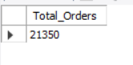
5.Average Pizzas Per Order
select sum(quantity)/count(distinct order_id) as AVg_Pizzas_Per_Order from pizza_sales;
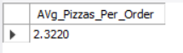
CHARTS REQUIREMENT
1.Daily Trend for Total Orders
select dayname(str_to_date(order_date,'%d-%m-%y')) as order_day,
count(distinct order_id) as total_orders from pizza_sales
group by order_day;
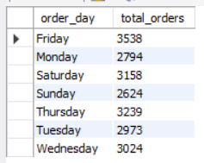
2.Hourly Trend for Total Orders
select hour(order_time) as order_hours,
count(distinct order_id) as total_orders from pizza_sales
group by order_hours;

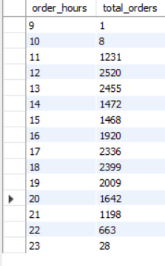
3.Percentage of Sales by Pizza Category
select pizza_category,sum(total_price)*100/(select sum(total_price) from pizza_sales) as Total_Sales from pizza_sales
group by pizza_category;
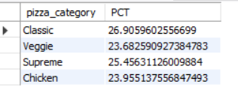
4.Percentage of Sales by Pizza Size
select pizza_size,cast(sum(total_price)*100/(select sum(total_price) from pizza_sales) as decimal(10,2)) as Total_Sales from pizza_sales
group by pizza_size;

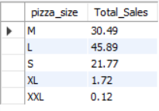
5.Total Pizzas sold by Pizza Category
select pizza_category,sum(quantity) from pizza_sales
group by pizza_category;

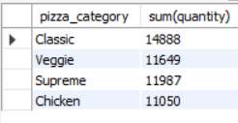
6.Top 5 Best Sellers by Total Pizzas Sold
select pizza_name,sum(quantity) as Total_Pizzas_Sold from pizza_sales
group by pizza_name
order by Total_Pizzas_Sold desc
limit 5;

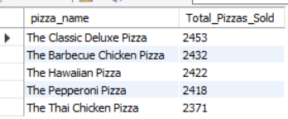
7.Bottom 5 Worst Sellers by Total Pizzas Sold
select pizza_name,sum(quantity) as Total_Pizzas_Sold from pizza_sales
group by pizza_name
order by Total_Pizzas_Sold Asc
limit 5;

